**Project Design Phase-II**

**Data Flow Diagram & User Stories**

|  |  |
| --- | --- |
| Date | 29 Jun 2025 |
| Team ID | LTVIP2025TMID47516 |
| Project Name | iRevolution: A Data-driven Exploration of Apple's iPhone Impact in India using Tableau |
| Maximum Marks | 4 Marks |

**Data Flow Diagrams:**

The Data Flow Diagram (DFD) for the “iRevolution” project illustrates the flow of data from multiple sources such as sales records, demographic datasets, and social media inputs (e.g., Twitter sentiment), into a centralized system. In the first stage, raw data is ingested and stored in a structured format within DB2 after cleaning and preprocessing. The second stage involves data transformation using SQL queries and Python-based sentiment analysis to extract key insights. In the final stage, processed data is visualized using Tableau to create interactive dashboards and stories. These visualizations are then embedded into a Flask-based web interface, enabling stakeholders like Apple, marketers, and analysts to interact with the insights for informed decision-making.

**Example:**

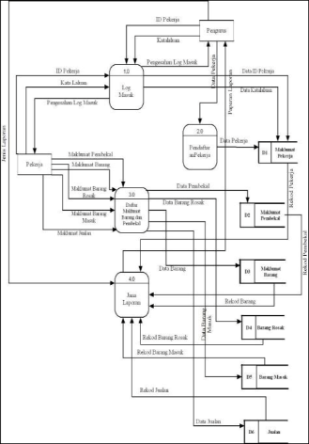

**User Stories**

Use the below template to list all the user stories for the product.

|  |  |  |  |  |  |  |
| --- | --- | --- | --- | --- | --- | --- |
| **User Type** | **Functional Requirement (Epic)** | **User Story Number** | **User Story / Task** | **Acceptance Criteria** | **Priority** | **Release** |
| Analyst / Developer | Data Collection | USN-1 | As a user, I can collect and upload the dataset into DB2 | Dataset is successfully loaded into the database | High | Sprint-1 |
| Analyst / Developer | Data Preparation | USN-2 | As a user, I can clean and transform the data using SQL queries | Cleaned data is available and usable in DB2 | High | Sprint-1 |
| Tableau Developer | Data Visualization | USN-3 | As a user, I can create sales trend visualizations in Tableau | Sales charts show clear regional/time-wise patterns | High | Sprint-2 |
| Tableau Developer | Data Visualization | USN-4 | As a user, I can create demographics-based dashboards | Dashboards display age, income, and city-based user segmentation | High | Sprint-2 |
| Tableau Developer | Data Visualization | USN-5 | As a user, I can visualize social media sentiment analysis | Positive/negative/neutral sentiment charts are available | Medium | Sprint-2 |
| Web User / Stakeholder | Dashboard Interaction | USN-6 | As a user, I can view Tableau dashboards on a web interface | Web UI loads dashboards embedded from Tableau | High | Sprint-3 |
| Web Developer | Web Integration | USN-7 | As a user, I can navigate between dashboards, reports, and stories via Flask UI | Pages are responsive and linked properly | Medium | Sprint-3 |
| Project Team | Reporting & Documentation | USN-8 | As a user, I can view a PDF/Word report of the analysis and project methodology | A downloadable, comprehensive report is provided | High | Sprint-4 |
| Project Team | Video Demonstration | USN-9 | As a user, I can watch a recorded explanation video of the entire project | A full video walkthrough is accessible via web or download | Medium | Sprint-4 |